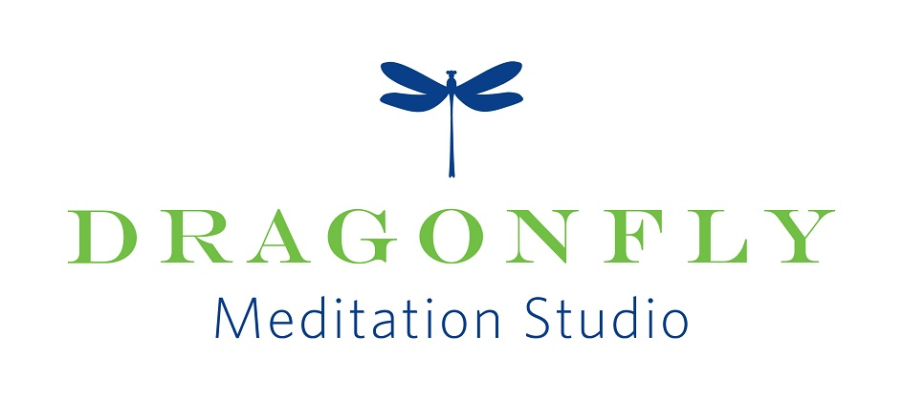
Practicing the art and science of mindfulness

Yoga for Back and Core
with Caroline Raffel CYT250
In this hatha yoga class:
*Practice holding postures to increase strength and create a healthy spine & strong inner core.
*Build a strong meditation posture and develop mindful posture habits.
*Attention is given to the breath and focus while building muscle strength and flexibility.
*Increase mind/body integration through a short dedicated meditation.
*Movements are done slowly and with mindfulness moving toward equal parts of ease and effort.
*All levels are welcome.
Date & Time: Tuesdays, July 25, August 1, 15, 29, September 5, 12, 26 at 6:45 pm – 7:45 pm
Date & Time: Fridays, July 21, 28, August 4, 18, 25, Sept. 1, 8, 15, 22, 29 at 9:45 am – 10:45 am

Yoga Nidra
with Caroline Raffel CYT250
Yoga Nidra is a guided scripted practice that helps one to reach the deepest state of relaxation that can be achieved while still being awake. Usually done while lying down with the support of blankets and cushions, Yoga Nidra may assist with the release of stress, trauma, chronic pain, and other physical and emotional ailments. Practicing Yoga Nidra helps you connect body, mind, and spirit. *No yoga experience is needed.
Date: Tuesdays, August 22, September 19
Time: 6:45 pm -7:45pm

To register: on line at dragonflymeditation.com
Pricing for all Yoga classes
Member passes: 5 for $45; drop in, $10 per class
Non-member passes: 5 for $50; drop in, $12 per class
Caroline is a 250 hour Certified Hatha and Yin Yoga Teacher and Certified Meditation Instructor. She has more than 25 years of experience teaching, leading, and facilitating groups of all ages on a variety of topics.
www.dragonflymeditation.com
11649 N Port Washington Rd. Suite #225 Mequon
262-518-0173
dragonfly@dragonflymeditation.com

